LEAF 2022 User Guide
Getting started with LEAF:

- Register and make an account using this link: https://app.ucl.ac.uk/LEAF/LEAF_External.
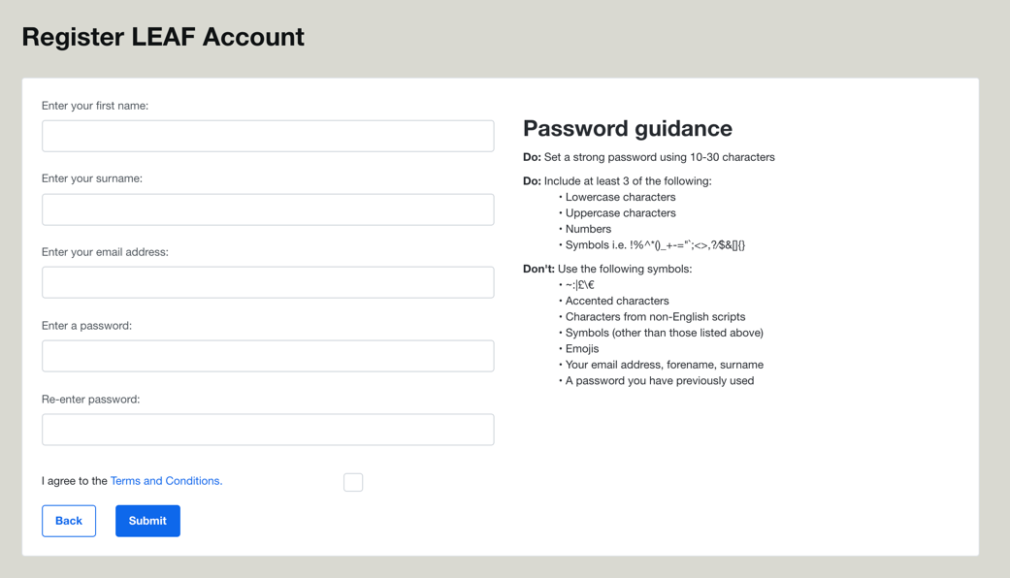

- Once you have made an account, sign in and request lab.
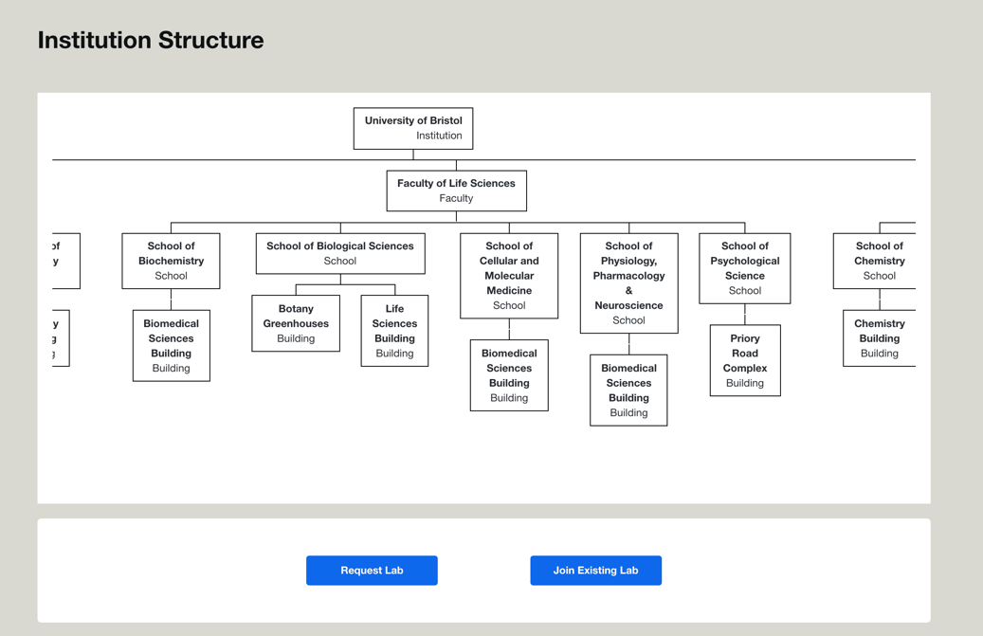

- Fill in your lab’s details to be reviewed and approved.
- Once your lab has been approved, you can begin completing the criteria in the report. If you have completed bronze or silver certification in the past and are going for higher certifications (i.e., silver or gold) you will have to copy and paste your answers from LEAF 2020 (the Microsoft excel document) for the criteria you have completed in the past – this will only have to be done once and will not have to be repeated for future certifications on this online platform.

Filling in the LEAF report:
1. When you are completing the LEAF report, try and be as thorough as possible with your answers and detail how each of the criterion have been met. Make use of the resources listed on Sharepoint, the Green Labs newsletters and LEAF Updates for helpful guidance.
2. You may find that some criteria do not apply to your lab space (eg. if there are no cold storage units present). If this is the case, put N/A and explain why the criterion is not relevant to your lab.
3. Make use of the LEAF calculators provided to work out your lab’s carbon and financial savings. The calculators automatically save your input as you use them, which can help document your lab’s progress throughout the year. Using the calculators is an optional step, but it helps quantify the impact of your sustainable actions and is a great way to maintain motivation.
4. Note down any other additional steps your lab has taken to improve sustainability that were not have been covered by the criteria in the “Open Initiatives” section. The Green Labs team would love to hear about any other sustainable actions taken or helpful tips your lab may have discovered!
5. When you have finished the LEAF report, click “submit” and a LEAF administrator will be in contact to arrange a virtual audit.

Preparing for the LEAF audit:
1. Audits will be conducted on Zoom or Teams and shouldn’t take longer than one hour to complete. It is best to take the call from a mobile phone. This way you can show the admin aspects of the lab which have been mentioned in the report.
2. The audit will begin with some questions about your experience of meeting the criteria, what was submitted in the report and any feedback your lab has about the whole process. LEAF and the Green Labs team is always welcoming of any constructive feedback that would help improve the initiative.
3. The admin will then ask to see aspects of the lab that were mentioned within the report. This could include signage, recycling points, freezer temperature readings, ACT labels, lab rotas and sample inventories, for example.
4. Prepare any documents ahead of the audit that the admin may want to look at. This could include a copy of induction presentations, evidence of booking systems, freezer info sheets and equipment breakdown procedures, for example.

For any further questions, please contact green-labs@bristol.ac.uk

